Christian Hernandez

Patrick Merrill

Mark Saweres

Lab 2

ScreenShot 1)

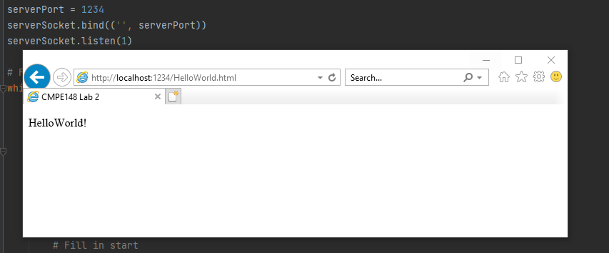

This screenshot shows that the contents of the HTML file were received from the server. This connection is from the local host on port 1234, retrieving the information from HellowWorld.html. HelloWorld.html is in the same directory as the server code.

Screenshot 2)

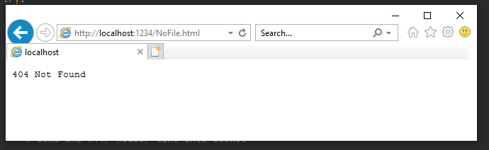

Because ‘NoFile.html’ is not present on the server, a “404 not found” message is presented.